Name:Mut Brus

Class:ITE G9A3

* Er diagram (image or PDF)
* 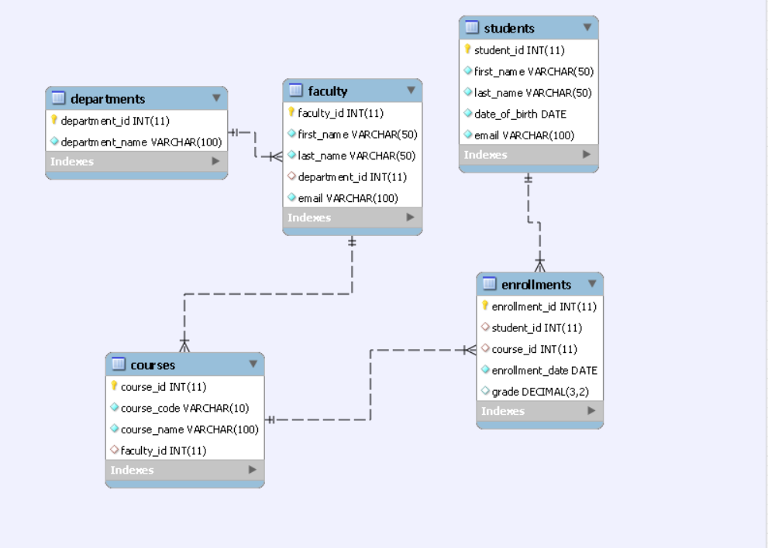

-SQL file create table and insert statement file



-sql queries with explanation

1. Retrieve all students who enrolled in a specific course.

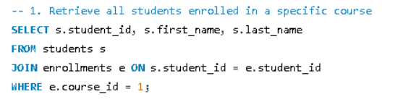

2. Find all faculty members in a particular department.

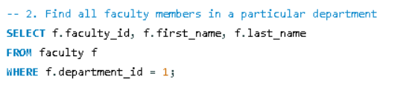

3. List all courses a particular student is enrolled in.

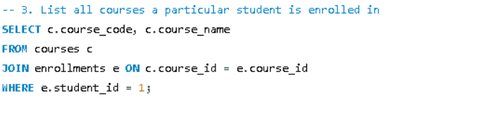

4. Retrieve students who have not enrolled in any course.

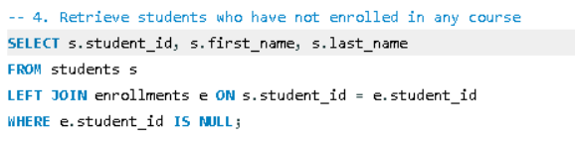

5. Find the average grade of students in a specific course

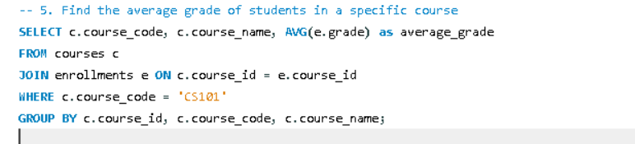

- screenshots of query results

1. Retrieve all students who enrolled in a specific course.

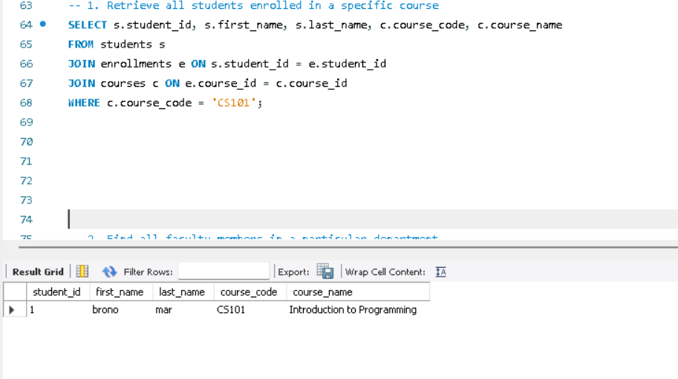

2. Find all faculty members in a particular department.

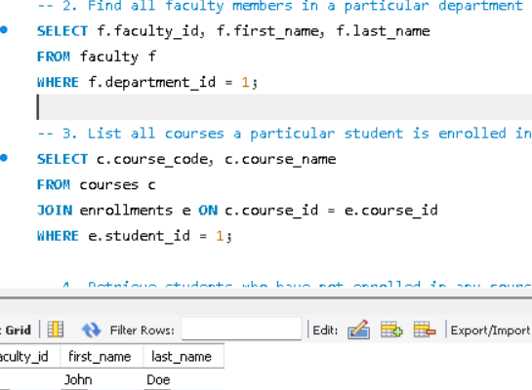

3. List all courses a particular student is enrolled in.

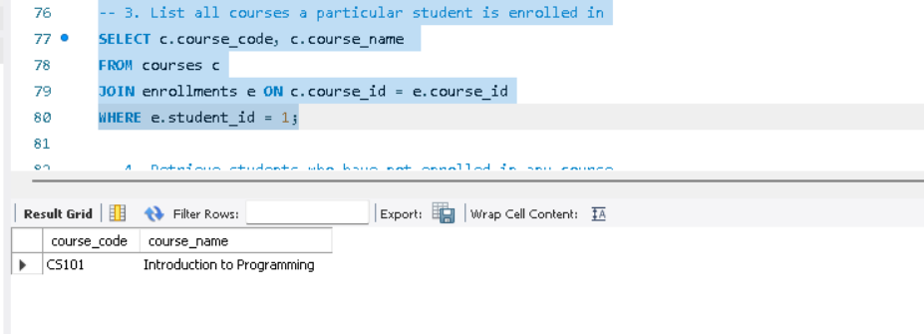

4. Retrieve students who have not enrolled in any course.

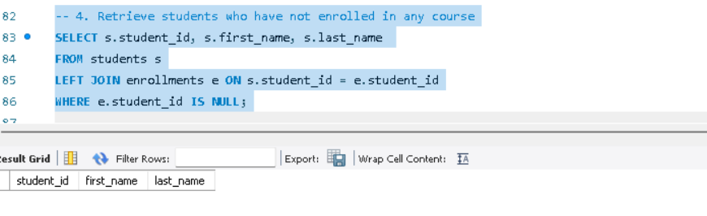

5. Find the average grade of students in a specific course

